


ENGLISH ASSIGNMENT 1.1

Topic: A cultural event-
HANAMI FESTIVAL

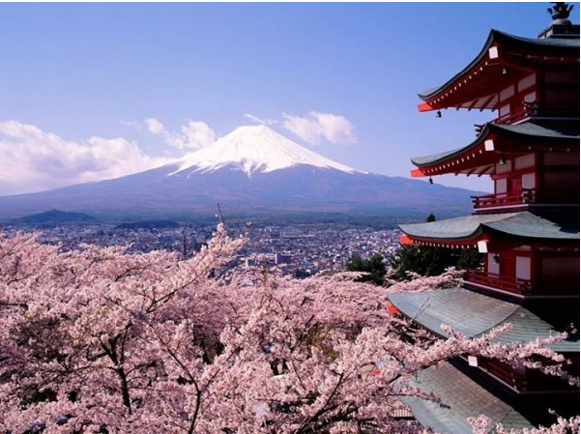

Teacher : | NguyenNH
Student : | Nguyen Quoc Tuan
SID : | PH08378
Class : | ENT1123.1

OUTLINE

- INTRODUCTION
Overviews of Hanami
II. BODY
1.Overviews of Hanami Festival
2. Traditional Food - Cultural Activities during Hanami Festival
3. My Experience and Feelings with Hanami
III. CONCLUSION

- Introduction
Overviews of Hanami
Japan is known around the world for its cherry blossom festival called “hanami” in Japanese, cherry blossom festival is an important custom and is held all over Japan during the spring. People said that “do not expect to see the flowers wherever you go, the trees bloom at differrent time throughout Japan”. If you’re planning a trip to the country in the spring, here’s what you need to known about the hanami festival.

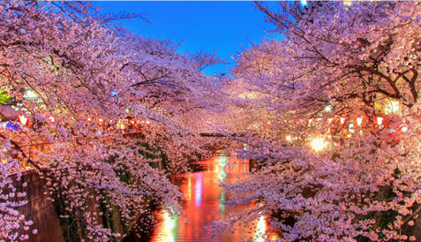

- Body
1. Overviews of Hanami Festival

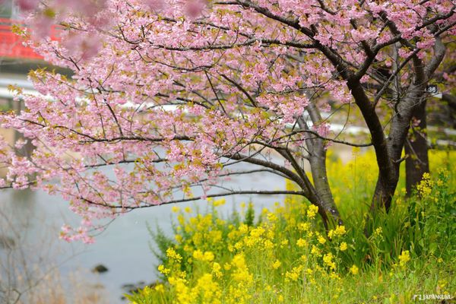

Hanami means watching flowes. It is an ancient tradition, when people will enjoy the sakura blossom and sometimes the plum blossom (ume) in the park and across the countryside in Japan. It is said that the origins of hanami began about 1000 years ago, when the rhymester looked at beautiful peach blossoms and wrote poems inspired by them.Unlike the old days, today people in Japan have given it an indispensable part of life. They drink and eat, making the tradition of the festival more like a picnic under a tree. People bring food at home or buy food to mark the occasion. When thousands of people flock to the park, making sure the nicer places for picnics and parties in public space really become competitive. Many of them will go early in the morning or even a day in advance, but there are many people who want to feel the festive atmosphere so they will be on the right spot even when there are no seats.
Cherry blossomed in January at Okinawa, and its reached their peak in late March to April in Honshu. In Hokkaido, cherry blossoms bloom in May. However, it is difficult to predict the cherry blossom day, so planning a trip is very difficult. So people usually watch the cherry blossom forecast every spring on the television.The cherry blossom festival takes place in different parts of the country. Each festival event area will be held differently but the atmosphere of the festival will never change.

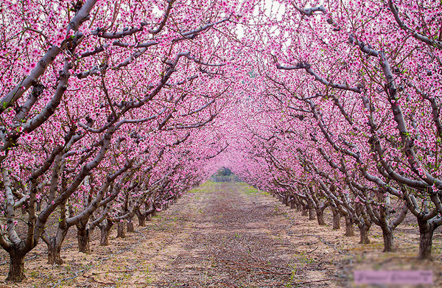

2. Traditional Food - Cultural Activities during Hanami Festival
2.1.Traditional Food

Hanami Festival in Japan is also often accompanied by parties and dance music. A number of traditional Japanese dishes are prepared for this occasion, such as sushi a familiar dish when it comes to Japan, it is often used right after being served, and served with soy sauce, wasabi and ginger pickled. When used to put the whole piece into the mouth to feel the full flavor in each ring. The strange taste of rice mixed with vinegar, the time and cool of the fish living together with the pungent smell of wasabi rushed to the nose. The most popular are tuna, squid and shrimp, served with cucumber, radish, and thinly sliced ​​eggs. There is also something else that is delicious and indispensable for this festival. " It is a type of Japanese rice wine commonly served with a variety of dishes. Sake is made from rice and water and is considered an alcoholic drink from ancient times. Because alcohol can be hot, "emotion" comes faster and warms the body in winter. When chilled wine will also have a similar taste to high quality wines. In every region of the country, there is a local winery with a distinct taste depending on the quality of rice and water as well as the differences in the production of wine.
All these things contribute to the festive atmosphere becoming more exciting.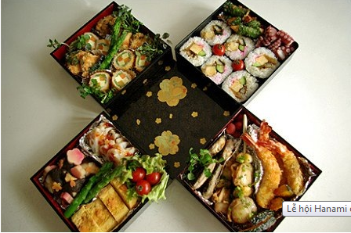

2.2 Japanese Cultural Activities
There are so many activities in this festival, if you don’t know, I will share some information of Hanami activities .Festival participants usually have traditional games such as the Japanese game Ohajiki. It was originally from China and was introduced to Japan from the Nara period. At that time there was no condition to produce ohajiki pictures with beautiful colors like now, so children of that time have to find the pebbles or pebbles to replace. Or Karuta game, it is one of the traditional New Year's games of the Japanese people appeared since the Edo period. Kataru is a rectangular set, quite similar to the western set of cards. However, the cards print pictures, letters or even poems. In addition, some of the main activities are procession to honor the gods who helped them.
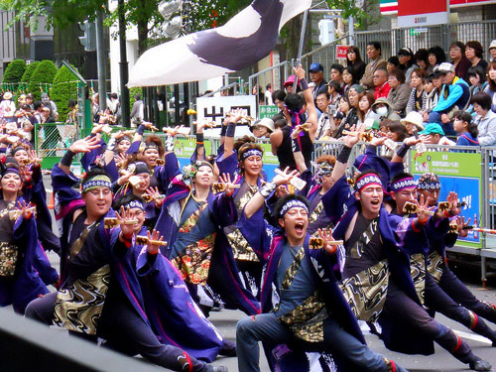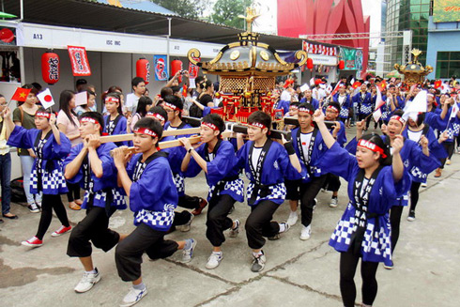

3. My Experiences and Feelings with Hanami festival
I participated in this festival in Vietnam, but not in Japan, it brought me a very interesting experience of the country of the sunrise. Although only a short time, the Hanami festival is expected to be one of the most prominent cultural events and attract a large number of tourists. When participating in the Hanami Festival in Vietnam, I have been exposed many traditional dishes such as 'ramen, soba, takoyaki', try wearing 'kimono, yukata', and watch the show of people Japanese people come here. Finally, I would like to share some tips to get the most beautiful flowers: "If you want to feel the freshness, the clarity of flowers, the day will be the best choice. Light, sweet, can visit the flowers in the morning light. ".

